 | DESCRIZIONE | PEZZI | VALORE | numero Pall
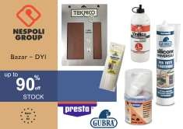 | CARTA ABRASIVA | 991 | 1.878,05 € | 1,5
 | KIT RIPARAZIONE | 184 | 3.385,60 €
 | COLLE | 2483 | 11.935,38 €
 | bazar DYS | 3658 | 17.199,03 €
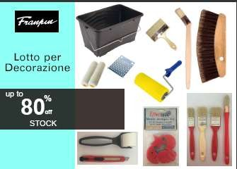 | RULLI IDEA | 1273 | 4.200,00 € | 7,5
 | PAINT | 1590 | 11.190,00 €
 | SPUGNE | 5372 | 36.529,00 €
 | Art. PER LA VERNICIATURA | 8235 | 51.919,00 €
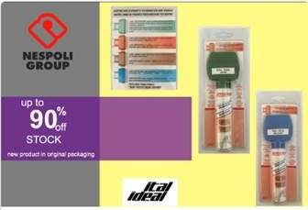 | PENNARELLI VERNICE ACRILICA | 3974 | 34.147,43 €
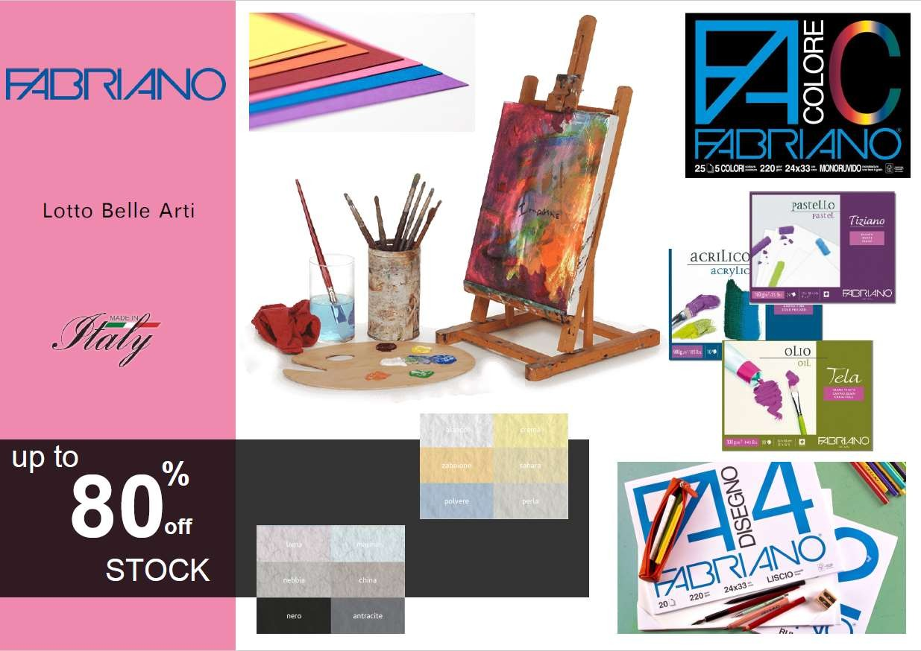 | FABRIANO | 749 | 6.450,00 € | 2
 | BELE ARTI | 600 | 5.052,50 €
 | BELLE ARTI | 5323 | 11.502,50 €
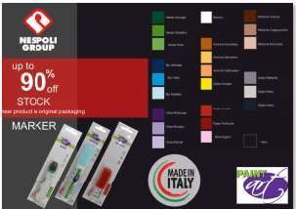 | DABO MARKER | 81094 | 868.869,00 € | 21
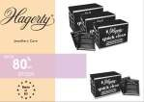 | HAGERTY | 2448 | 24.480,00 € | 1
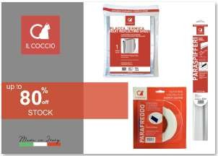 | SIFERPLAST PARAFGREDDO | 4000 | 7.600,00 € | 3
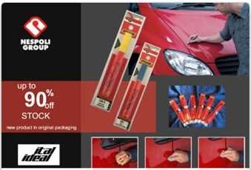

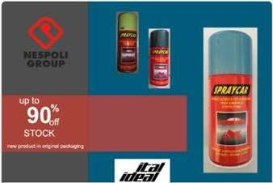
 | Touch-up Pens 14700 | 14710 | 67.686,83 € | 12
 | SPRAY AUTO 150ML | 24632 | 111.842,35 €
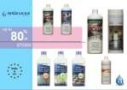 | BELLINZONI | 4916 | 41.992,35 € | 5
 |  |  | pallet | 53
 | TOT | 152990 | 1.237.238,50 €

